**Yifeng Huang**

**ART101 - Programming for the Arts 2024 Spring Quarter**

**Lab 8: Anon Functions and Callbacks 5/6/2024**

**Links to the lab assignment result**

Home Page: <https://yhuan359.github.io/art101>

This Lab page: <https://yhuan359.github.io/art101/lab8/index.html>

**Summary of Efforts**

Learning about anon functions and callbacks is fun because of how “anonymous” these functions feel running in the background without you acknowledging their presence. Anon functions and callbacks. It’s the equivalent of walking into an empty museum display and seeing a blank piece of art before looking closer to see what the art piece is really trying to say.

**Screenshots:**

**Task 1: Create an index.html for Lab 8**

**Task 2: Experiment in the Console**

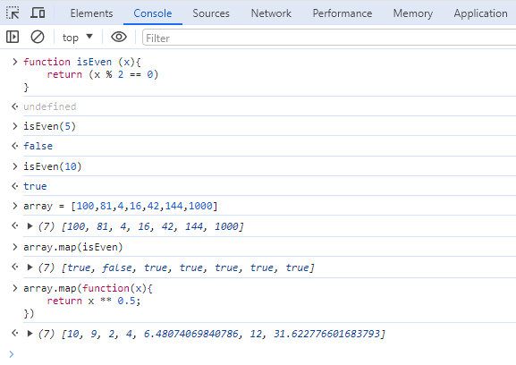

**Task 3: Create a JavaScript file**

**Task 4: Debug, Upload, and Test**

**Self-Evaluation Rubric**

|  |  |  |  |  |  |  |
| --- | --- | --- | --- | --- | --- | --- |
| Self-Evaluation Rubric | | | | | | |
| Did you complete the assignment and did you complete it on time? | Submitted on time | Up to 1 day late | Up to 2 days late | Up to 3 days late | Up to 4 days late | **Do you need to clarify?** |
| 口 | 口 | 口 | 口 | 口 |  |
| Did you collaborate with a partner? | A lot of effort |  | Some effort |  | Not this time | **Do you need to clarify?** |
| 口 |  | 口 |  | 口 |  |
| Did you put in earnest effort and provide an articulate summary of your experience? | Excellent | Pretty good | About average | Could be improved | Not this time | **What supports this?** |
| 口 | 口 | 口 | 口 | 口 | I followed the instructions and made this very simple. |
| Was the assignment complete, with minimal errors, correct output, and good style? | Excellent | Pretty good | About average | Could be improved | Not this time | **What supports this?** |
| 口 | 口 | 口 | 口 | 口 | I reviewed the script multiple times to make sure nothing was wrong before debugging it correctly |
| How much EXTRA effort did you put into the assignment? | A lot of extra effort |  | Some extra effort |  | Not this time | **What supports this?** |
| 口 |  | 口 |  | 口 |  |
| **Summary of your evaluation/efforts:** | | | | | | |
| Working with anon functions and callbacks allows me to play around more with my console area in this assignment. I almost got lost only because I have to evaluate both scripts to make sure they were both free of errors. | | | | | | |